GovSecure AI Chef™
Enterprise AI Governance Recipe Matrix Toolkit
v1.0 - 24 Core Recipes
A practical operational toolkit for governing AI risks, controls, ownership, and assurance across the enterprise.
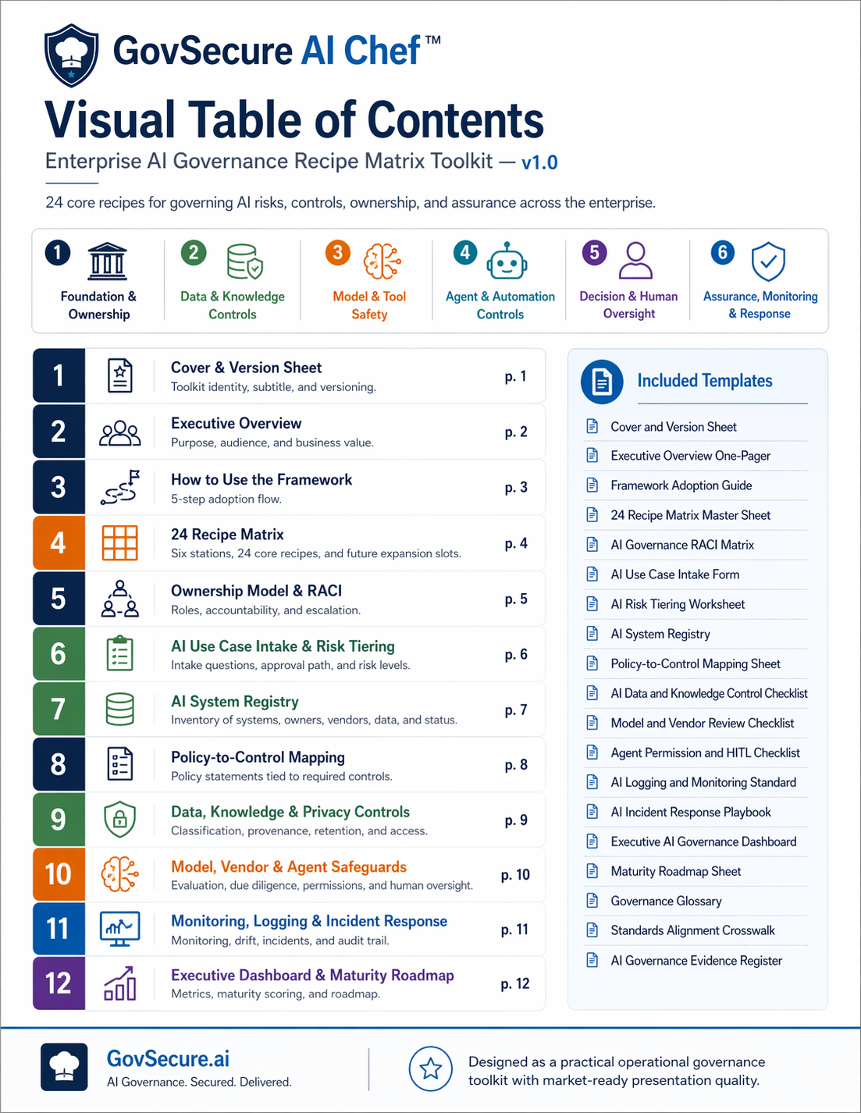
Built from the approved GovSecure AI Chef toolkit outline and template structure.

Executive Overview
GovSecure AI Chef turns AI governance from scattered policies into an operating model with named ownership, risk-tiered intake, mapped controls, evidence expectations, and leadership reporting.
The toolkit is designed for SMB owners, CIO/CISO leaders, compliance teams, and AI governance practitioners who need one framework that can support awareness, implementation, and audit readiness without becoming theoretical sludge.
What is included
- A 24-recipe governance matrix across six stations
- An ownership and RACI model
- AI use-case intake and risk tiering workflow
- AI system registry structure
- Policy-to-control mapping baseline
- Operational guidance for data, model, vendor, agent, monitoring, and incident controls
- A maturity roadmap from 24 to 36 recipes
How to Use the Framework
Use the toolkit in five steps:
- 1. Identify AI systems and use cases
- 2. Assess the use case and assign a risk tier
- 3. Assign owners and supporting functions
- 4. Implement required controls and record evidence
- 5. Review quarterly and improve by maturity stage
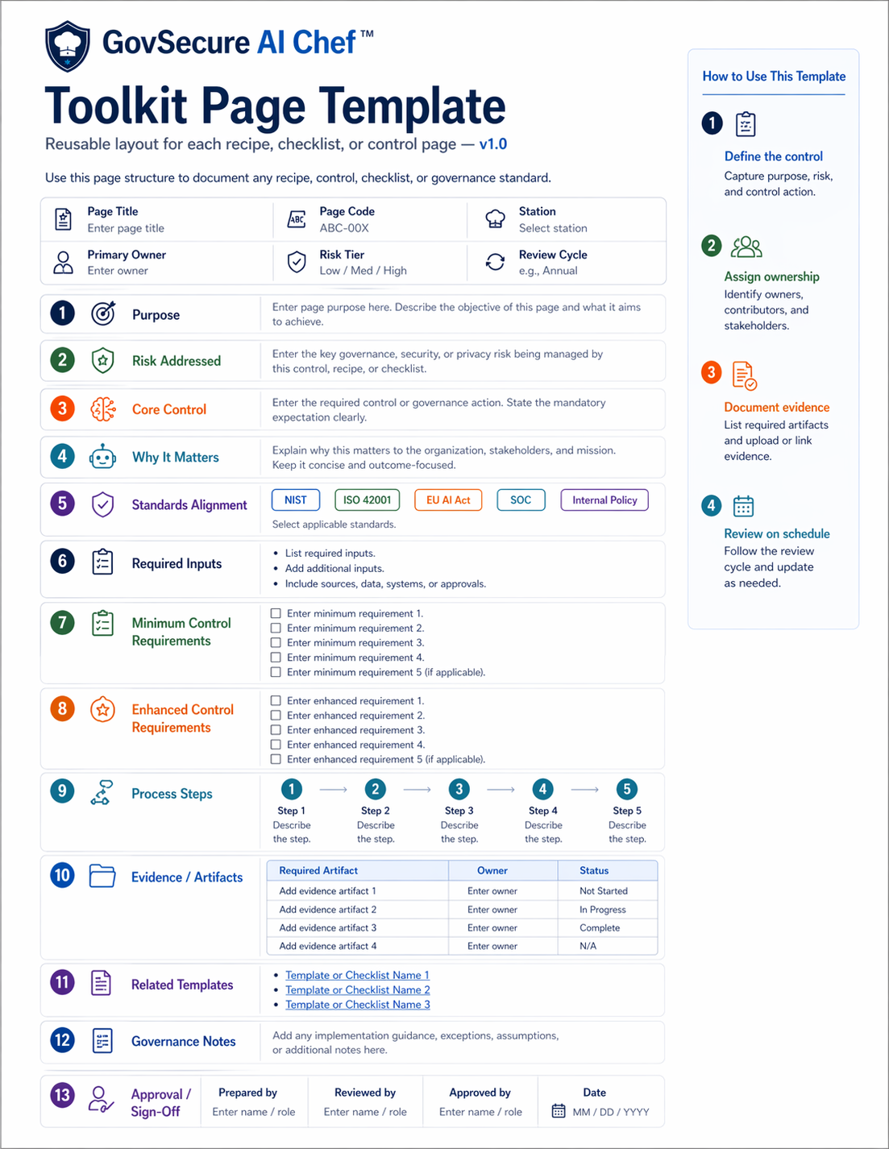

24 Core Recipes Matrix
Station | Code | Recipe | Core Control | Owner
Foundation & Ownership | Ow | Head Chef Assignment  Risk: Ownership Vacuum | Assign named AI governance owner, charter, RACI, escalation authority | EX / AG
 | Pg | Kitchen Rules  Risk: Policy Gaps | Set AI policy, acceptable use, prohibited use, and exception handling | LE / SE / AG
 | Rc | Role Recipe Card  Risk: Role Confusion | Define responsibilities across IT, Security, Legal, Privacy, Data, Procurement, HR, and business | AG
 | Sa | Approved Menu Only  Risk: Shadow AI | Maintain approved tools register and sanctioned use pathways | IT / SE
Data & Knowledge Controls | Di | Clean Ingredients  Risk: Sensitive Data Exposure | Apply data classification and prompt handling restrictions | DA / PR / SE
 | Pv | Source Provenance Check  Risk: Untrusted or Poor-Quality Data | Track provenance, metadata, and approved knowledge sources | DA
 | Rd | Retention & Disposal Recipe  Risk: Over-Retention | Define AI-specific retention and deletion rules | PR / IT
 | Kb | Knowledge Base Boundaries  Risk: Unauthorized Retrieval | Enforce permission-aware retrieval and connector controls | IT / SE / DA
Model & Tool Safety | Ev | Pre-Serve Evaluation  Risk: Unsafe Deployment | Test performance, robustness, misuse, and bias before production | BU / SE / AG
 | Ss | Secret Sauce Lockdown  Risk: Embedded Secrets Exposure | Use vaulting, secret scanning, and protected authentication | EN / SE
 | Dt | Drift Tasting  Risk: Behavioral Drift | Revalidate against benchmarks and review thresholds | BU / EN
 | Vr | Vendor Pantry Review  Risk: Third-Party AI Exposure | Perform AI-specific vendor, legal, and security due diligence | PC / SE / LE
Agent & Automation Controls | Tp | Tool Permission Gate  Risk: Agent Overreach | Apply least privilege, scoped tool access, and action thresholds | IT / SE
 | Hi | Human Before High Impact  Risk: Unchecked Automation | Require human approval for high-impact actions | BU / AG
 | Sb | Sandbox Before Service  Risk: Unsafe Rollout | Use staging, pilots, rollback design, and controlled releases | EN / IT
 | Ks | Kill Switch on the Counter  Risk: Runaway Behavior | Enable emergency disablement and connector revocation | SE / IT
Decision & Human Oversight | Ex | Explain the Dish  Risk: Opaque Outputs | Require rationale, notices, and traceability where appropriate | BU / LE
 | Ea | Escalate Ambiguous Orders  Risk: Harmful Outcomes | Define exception triggers and human escalation rules | BU
 | Bt | Bias & Fairness Taste Test  Risk: Unfair Outcomes | Conduct fairness review and remediation for high-impact uses | LE / BU / AG
 | Hr | High-Risk Use Case Flag  Risk: Sensitive Use Cases | Apply intake triage, risk tiering, and enhanced approval | AG
Assurance, Monitoring & Response | In | Full Kitchen Inventory  Risk: Unknown AI Systems | Maintain AI system registry with owners, vendors, data, and status | AG / IT
 | Lg | Kitchen Camera Logs  Risk: Weak Auditability | Log prompts, tool calls, approvals, changes, exceptions, and incidents | SE / IT
 | Ir | Burn Response Plan  Risk: No AI Incident Handling | Create AI incident response playbook | SE / PR / LE / IT
 | Qr | Quarterly Recipe Review  Risk: Control Decay | Review metrics, open risks, exceptions, and maturity quarterly | AG / EX

Ownership Model and RACI
Primary roles
- Executive Sponsor (EX): accountably backs the program and clears roadblocks.
- AI Governance Lead (AG): operates the framework, intake, reviews, and reporting.
- IT / Platform Owner (IT): manages enablement, access, integration, and platform controls.
- Security (SE): enforces security controls, monitoring, and incident coordination.
- Privacy (PR): covers personal-data handling, retention, and privacy reviews.
- Legal / Compliance (LE): addresses regulatory, contractual, and policy interpretations.
- Data Owner / Governance (DA): owns data quality, provenance, and approved access.
- Business Owner (BU): owns the use case, benefits, and outcome accountability.
- Procurement / Vendor Risk (PC): performs third-party diligence and contract coordination.
- Engineering / Product (EN): implements technical safeguards and rollout design.
Sample RACI snapshot
Recipe | EX | AG | IT | SE | BU
Head Chef Assignment | A | R | C | C | I
Approved Menu Only | I | C | R | A | C
High-Risk Use Case Flag | C | A | I | C | R
Burn Response Plan | C | C | R | A | I
Escalation path: Business Owner -> AI Governance Lead -> Security/Privacy/Legal as needed -> Executive Sponsor for Tier 4 or exception approvals.

AI Use Case Intake and Risk Tiering
Required intake questions
- Business purpose and intended outcome
- AI capability type and provider
- Internal-only or external/customer-facing use
- Data sensitivity and regulated-data exposure
- Decision impact and human oversight requirement
- Automated actions or tool permissions
- Third-party/vendor dependence
- Applicable regulations or contractual obligations
Risk tier logic
Tier | Label | Use | Default expectation
1 | Low | Internal productivity with low sensitivity | Standard controls and owner assignment
2 | Moderate | Business workflow support with moderate data sensitivity | Documented review and evidence requirements
3 | High | Sensitive data, consequential outputs, or customer impact | Enhanced controls and multi-function approval
4 | Prohibited / Executive Review | Unsafe, disallowed, or materially high-risk use | Block or route to Executive Sponsor

Policy-to-Control Mapping Baseline
Use this baseline to turn policy language into minimum and enhanced operational controls.
Policy Theme | Required statement | Minimum control | Enhanced control | Evidence
Acceptable Use | Use approved tools only for approved purposes | Approved tools register and owner assignment | Periodic usage review and exception workflow | Tool list, approvals
Data Handling | Do not expose sensitive data without authorization | Classification and input restrictions | DLP, redaction, connector segmentation | Classification guidance, logs
Human Oversight | High-impact outputs require human review | Defined approval threshold | Dual approval or specialist sign-off | Review records
Vendor Review | Third-party AI providers require diligence | Security/legal review | Ongoing reassessment and contract safeguards | Vendor review pack
Logging & Monitoring | Material AI activity must be auditable | Prompt/tool/approval logging | Alerting, anomaly checks, and periodic review | Logs, review summaries
Incident Response | AI incidents must be escalated rapidly | AI incident categories and owner list | Playbooks, tabletop tests, lessons learned | Incident tickets, PIRs

AI Incident Response Playbook
Incident categories
- Harmful or misleading output
- Privacy breach or unauthorized data exposure
- Security exposure or embedded secret disclosure
- Model or agent drift causing unsafe behavior
- Unauthorized automation or unapproved integration
- Third-party vendor or service failure
Workflow
- Detect and triage
- Assess severity and impacted systems
- Contain or disable affected AI activity
- Escalate to Security, Privacy, Legal, and Executive Sponsor as required
- Remediate and restore safe operation
- Review root cause, evidence, and control improvements
Minimum evidence: incident summary, owner, timeline, impacted data/systems, containment action, recovery decision, lessons learned.

Governance Glossary
AI system: Any model, tool, agent, workflow, or embedded capability used to generate, classify, retrieve, recommend, or automate decisions.
Agent: An AI-enabled system that can invoke tools, call external systems, or take actions toward a task.
High-impact use case: A use case whose output can materially affect people, finances, legal posture, privacy, or safety.
Human oversight: A defined review or approval action by a responsible human before or after AI output is used.
Model drift: A measurable change in behavior, performance, or output quality over time that can affect reliability or safety.
Shadow AI: Use of AI tools or capabilities outside approved governance, visibility, or control.
Knowledge base: A collection of internal or external documents and data sources used to ground or enrich AI outputs.
Prohibited use: A use case that the organization forbids because the risk cannot be reduced to an acceptable level.
Standards Alignment Crosswalk
Reference only - not a legal certification claim.
Framework area | NIST AI RMF | ISO/IEC 42001 | EU AI Act themes | SOC-style logic
Foundation & Ownership | Govern | Leadership, policy | Governance, QMS | Control environment
Data & Knowledge | Map / Manage | Data governance | Data governance | Confidentiality / Privacy
Model & Tool Safety | Measure / Manage | Lifecycle controls | Accuracy, robustness, cybersecurity | Processing integrity / Security
Monitoring & Response | Manage | Monitoring, improvement | Logging, oversight | Monitoring / Change management
AI Governance Evidence Register
- AI policy and approved tools list
- Use-case intake records and risk assessments
- AI system inventory
- Vendor review records
- Monitoring logs and exception records
- Incident reports and quarterly review decks

